**Install Cacti Monitoring Tool on CentOS 8 / RHEL 8**

#### Step 1) Install Apache web server

[root@observium ~]# dnf install httpd -y

#### Step 2 ) Install PHP and additional PHP extensions

[root@observium ~]# dnf install -y php php-xml php-session php-sockets php-ldap php-gd php-json php-mysqlnd

#### Step 3) Install MariaDB database server

[root@cacti ~]# yum install @mariadb -y

[root@observium ~]# dnf install -y mariadb-server mariadb

[root@cacti ~]# systemctl enable mariadb.service

[root@cacti ~]# systemctl start mariadb.service

[root@cacti ~]# systemctl status mariadb.service

[root@cacti ~]# firewall-cmd --permanent --add-service=mysql

[root@cacti ~]# firewall-cmd --reload

[root@centos8 ~]# mysql_secure_installation

#### Step 4) Install SNMP and RRD tool

Next, we are going to install SNMP and RRDtool which are essential in gathering and processing system metrics.

[root@observium ~]# dnf install -y net-snmp net-snmp-utils net-snmp-libs rrdtool

**Step 5)  Start and enable services**

Having installed all the necessary services required for Cacti to run, we are going to start them as shown:

[root@observium ~]# systemctl start httpd

[root@observium ~]# systemctl start snmpd

[root@observium ~]# systemctl start mariadb

Additionally, ensure to enable them on boot, such that they automatically start upon booting or a reboot.

[root@observium ~]# systemctl enable httpd

[root@observium ~]# systemctl enable snmpd

[root@observium ~]# systemctl enable mariadb

#### Create a database for Cacti

[root@cacti ~]# mysql -u root -p

MariaDB [(none)]> CREATE DATABASE cacti;

MariaDB [(none)]> GRANT ALL ON cacti.* TO cactiuser@localhost IDENTIFIED BY 'cactipassword';

MariaDB [(none)]> ALTER DATABASE cacti CHARACTER SET utf8mb4 COLLATE utf8mb4_unicode_ci;

MariaDB [(none)]> flush privileges;

MariaDB [(none)]> exit

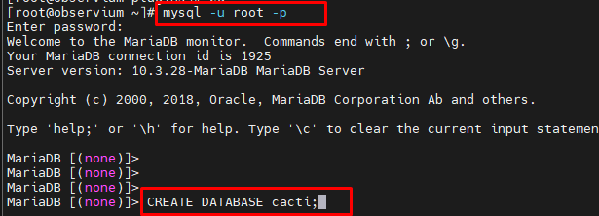

[root@observium ~]# mysql -u root -p mysql < /usr/share/mariadb/mysql_test_data_timezone.sql

[root@observium ~]# mysql -u root -p

MariaDB [(none)]> GRANT SELECT ON mysql.time_zone_name TO cactiuser@localhost;

MariaDB [(none)]> flush privileges;

MariaDB [(none)]> exit

#### Installing and configuring Cacti monitoring tool

[root@observium ~]# dnf install epel-release -y

[root@observium ~]# yum -y install cacti

[root@observium ~]# rpm -qi cacti

[root@observium ~]# rpm -ql cacti | grep cacti.sql

[root@observium ~]# mysql cacti < /usr/share/doc/cacti*/cacti.sql -u root -p



[root@observium ~]# vim /usr/share/cacti/include/config.php

/* make sure these values reflect your actual database/host/user/password */

$database_type = "mysql";

$database_default = "cacti";

$database_hostname = "localhost";

$database_username = "cactiuser";

$database_password = "cactipassword";

$database_port = "3306";

$database_ssl = false;

[root@observium ~]# vim /etc/cron.d/cacti

Uncomment the following entry to poll every five min.

*/5 * * * * apache /usr/bin/php /usr/share/cacti/poller.php > /dev/null 2>&1

Set the timezone by editing /etc/php.ini file.

[root@observium ~]# vim /etc/php.ini

Update the timezone.

date.timezone = Asia/Dhaka

memory_limit = 512M

max_execution_time = 60

[root@cacti ~]# service php-fpm restart

[root@observium ~]# vim /etc/httpd/conf.d/cacti.conf

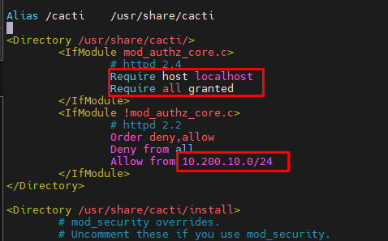

[root@observium ~]# systemctl restart httpd

[root@observium ~]# firewall-cmd --permanent --add-service=http

[root@observium ~]# firewall-cmd --reload

[root@mrtg ~]# vim /etc/my.cnf.d/mariadb-server.cnf

Add variables in the [mysqld] section.

collation-server = utf8mb4_unicode_ci

character-set-server=utf8mb4

max_heap_table_size = 64M

tmp_table_size = 64M

join_buffer_size = 64M

innodb_file_format = Barracuda

innodb_large_prefix = 1

innodb_flush_log_at_timeout = 3

innodb_buffer_pool_size = 1GB

innodb_buffer_pool_instances = 10

# Based on what type for storage you use. The below values are for SSD drives.

# Change it if Cacti reports issues during the installation

innodb_read_io_threads = 32

innodb_write_io_threads = 16

innodb_io_capacity = 5000

innodb_io_capacity_max = 10000

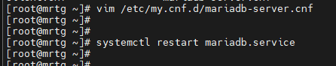

**Set the SELinux context for Cacti logs:**

[root@observium ~]# yum install -y policycoreutils-python

[root@observium ~]# semanage fcontext -a -t httpd_sys_rw_content_t "/var/log/cacti(/.*)?"

[root@observium ~]# restorecon -Rv /var/log/cacti/

[root@localhost ~]# vim /usr/share/cacti/log/

[root@localhost ~]# setenforce 0

[root@localhost ~]# systemctl restart httpd.service

[root@localhost ~]# systemctl restart mariadb.service

<http://your-ip-address/cacti>

<http://10.200.10.52/cacti>

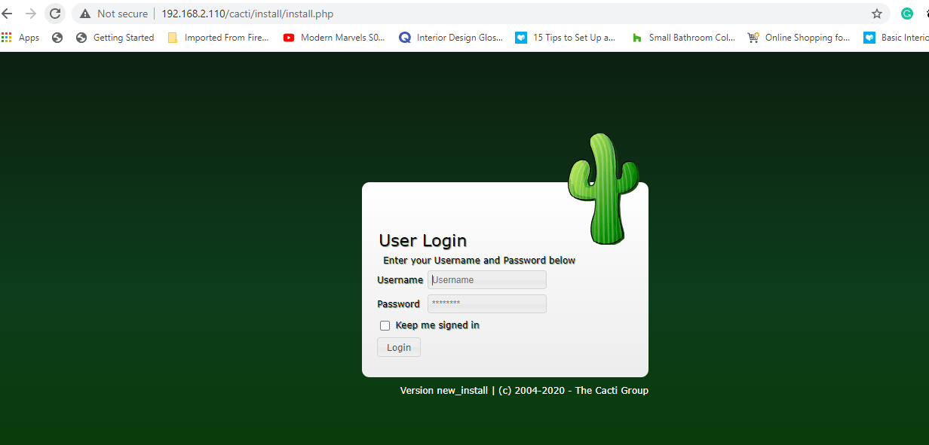

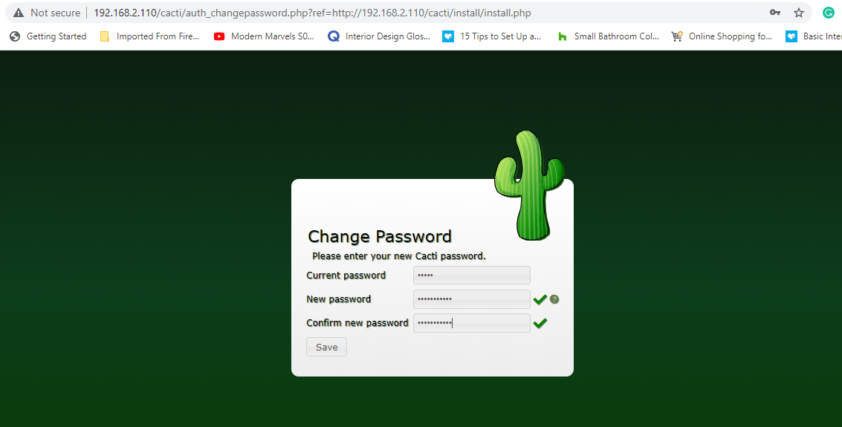

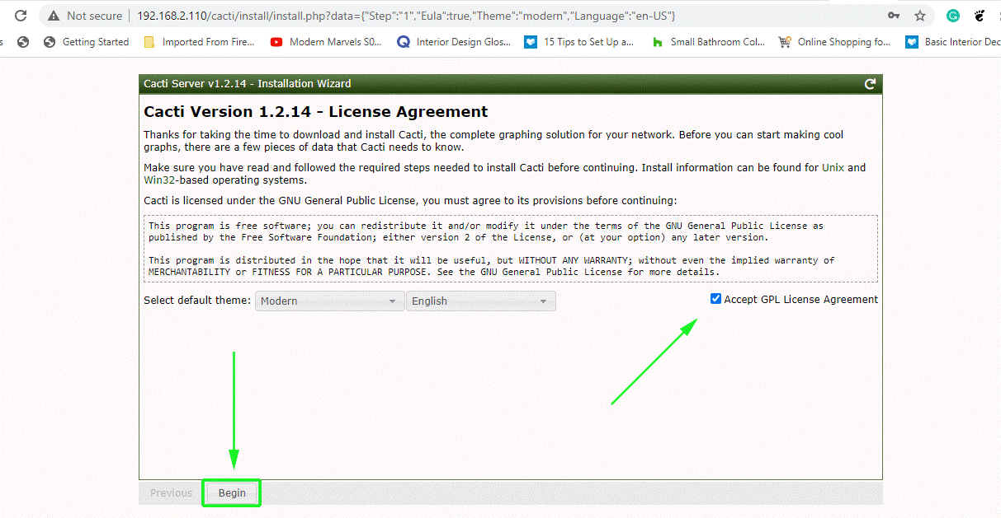

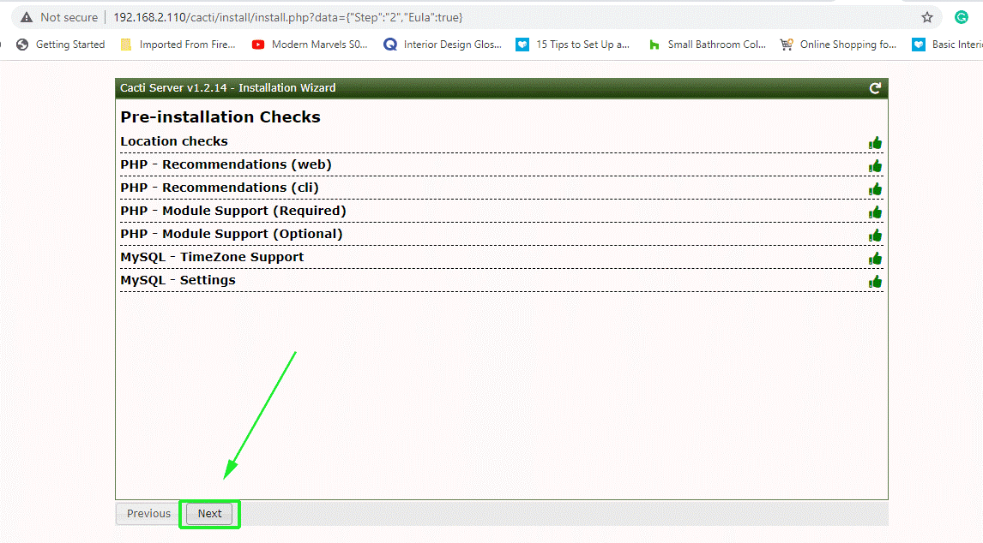

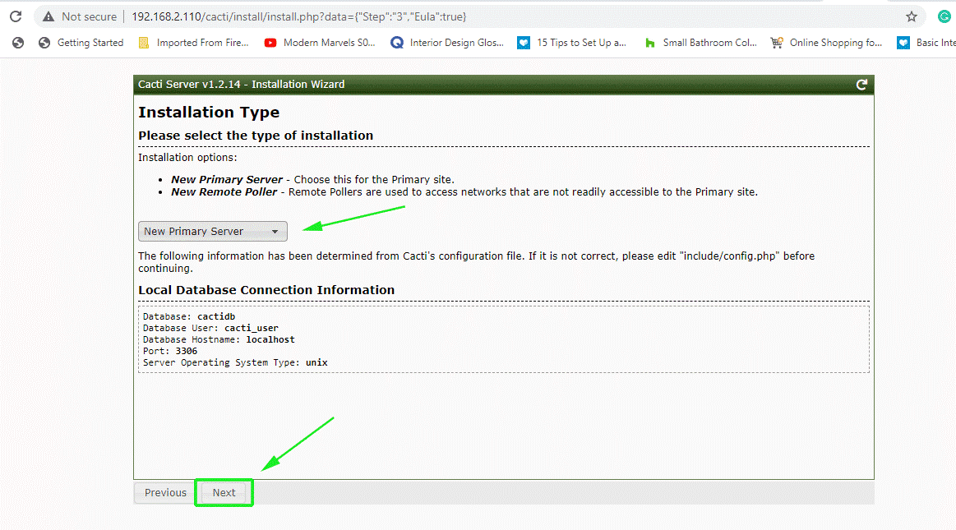

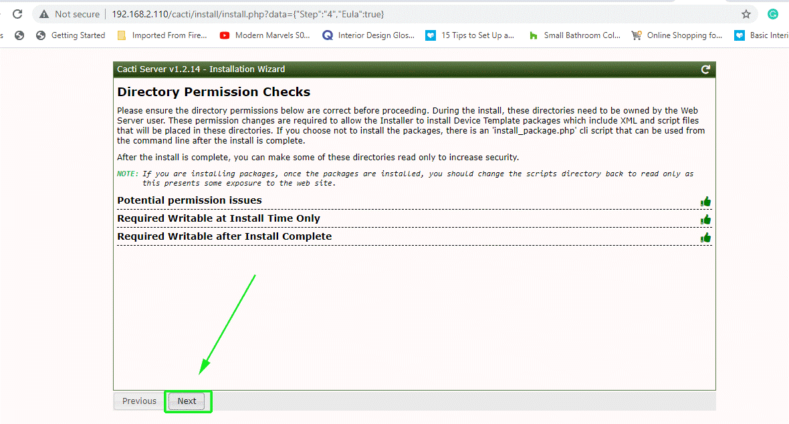

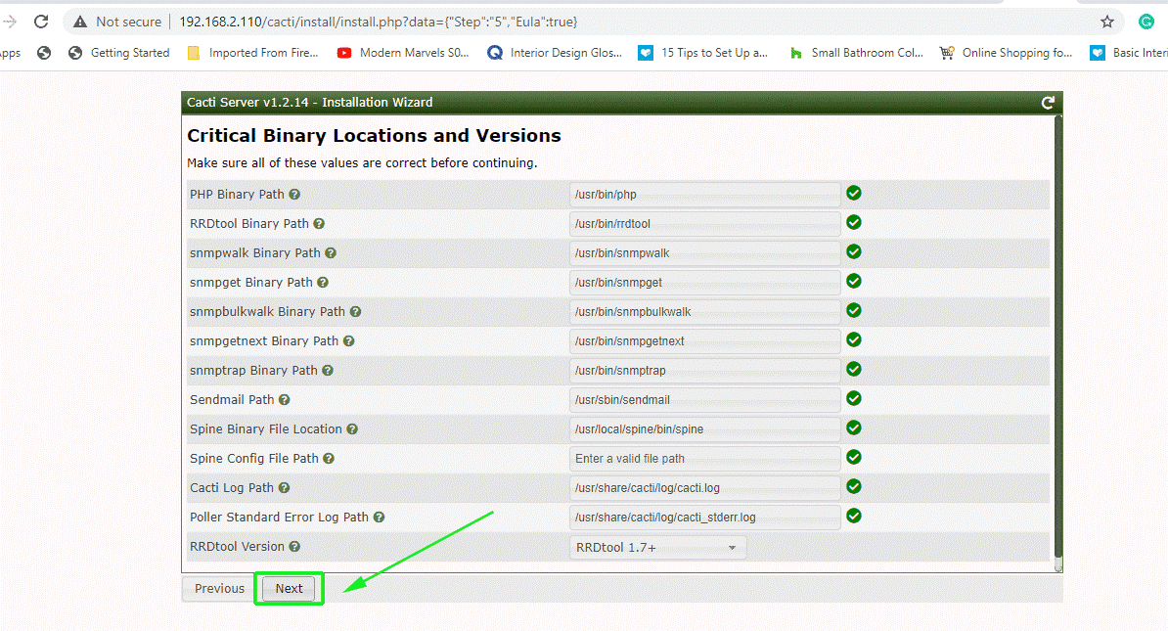

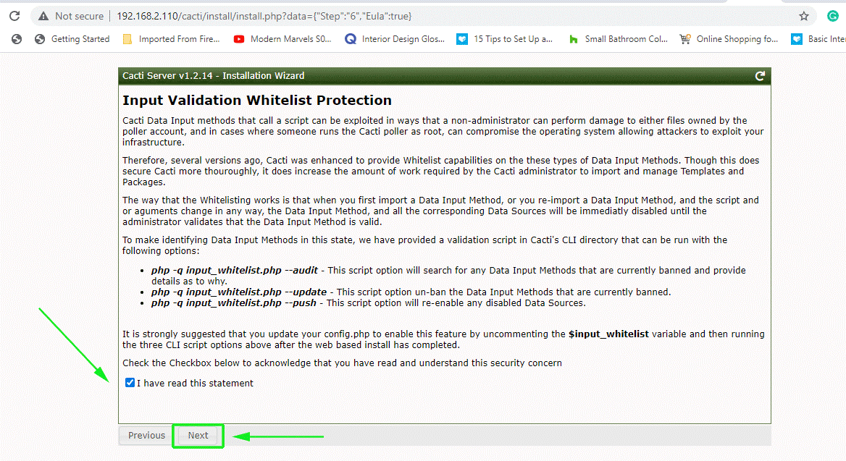

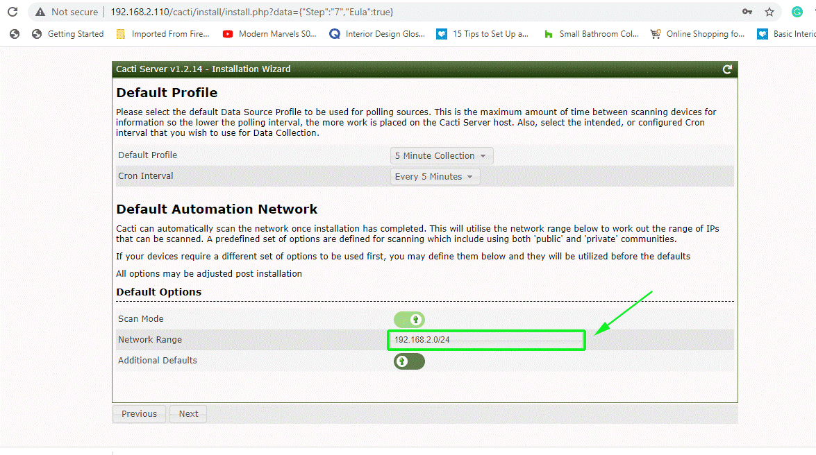

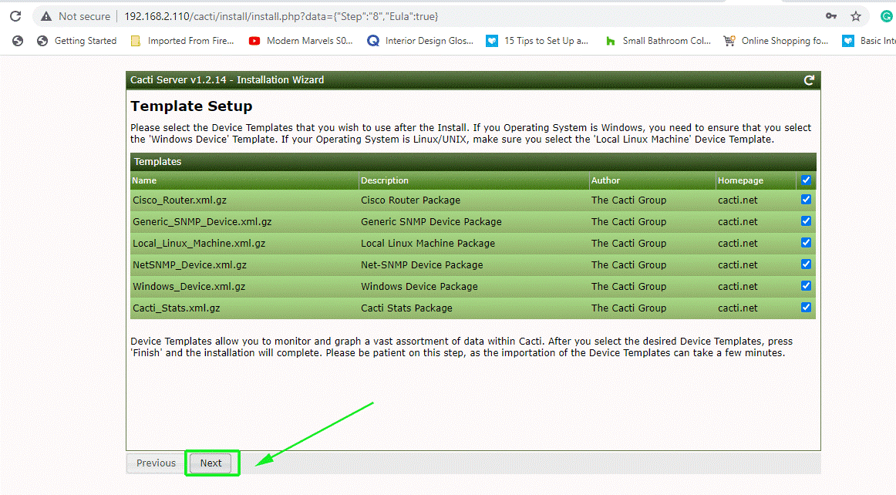

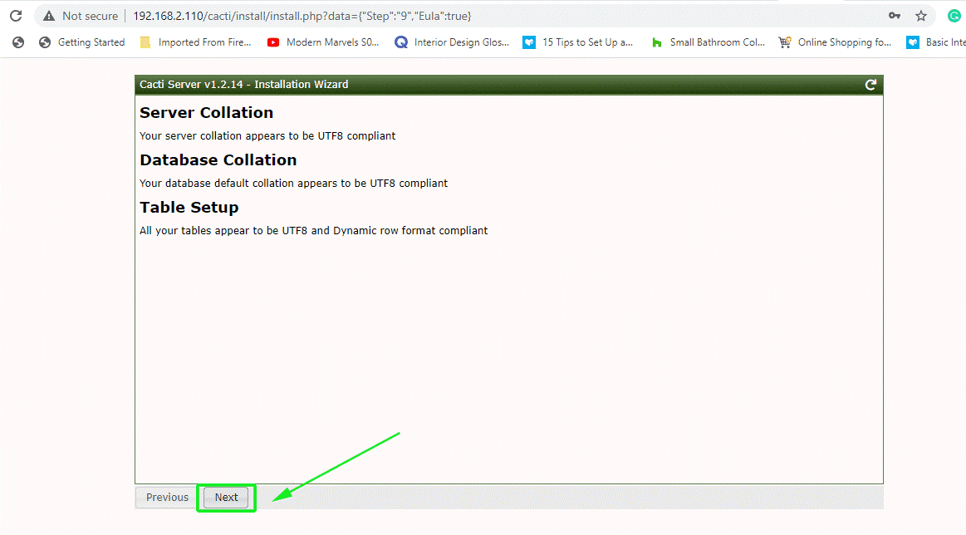

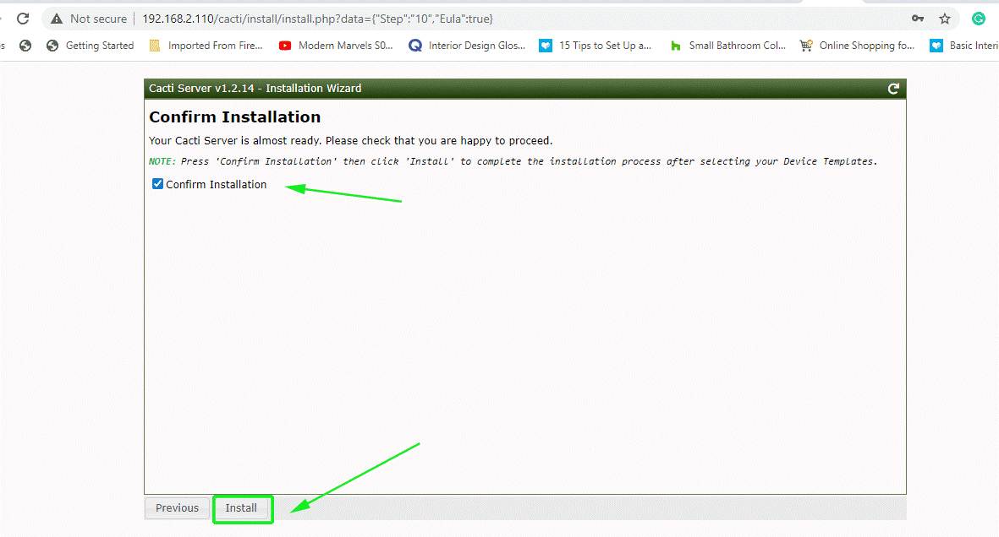

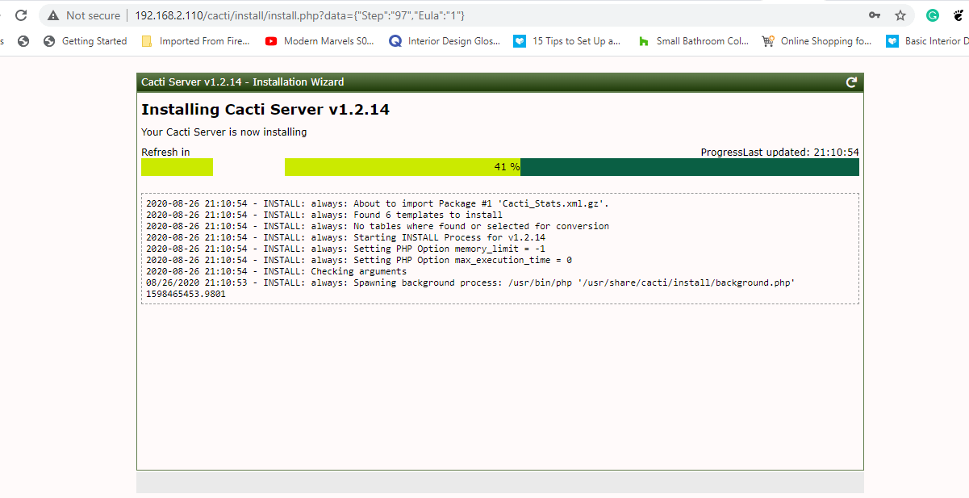

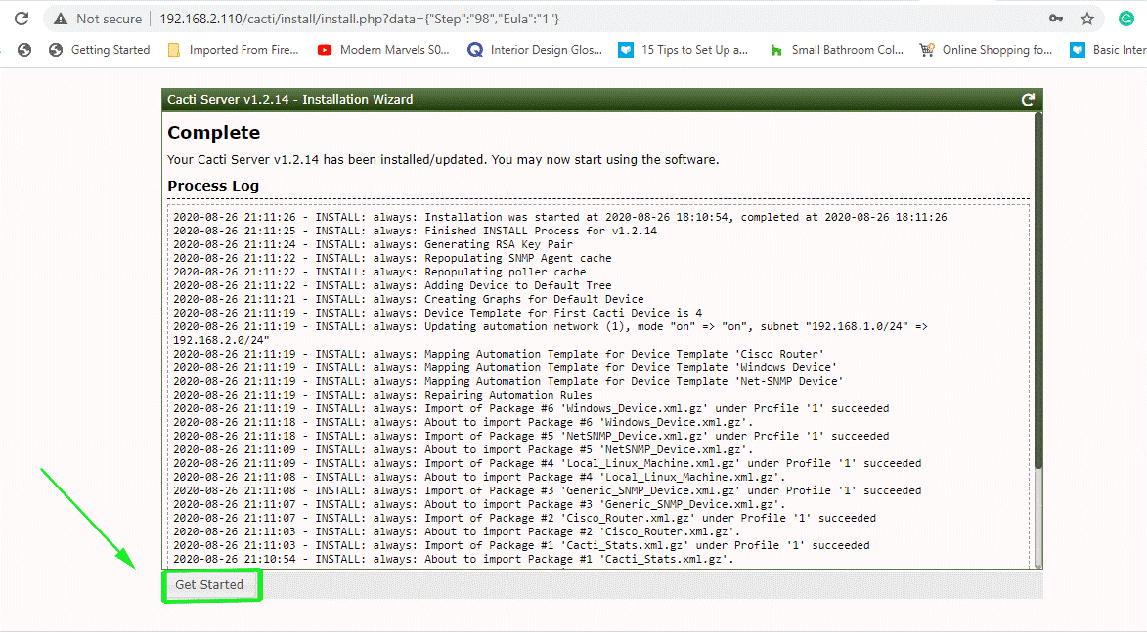

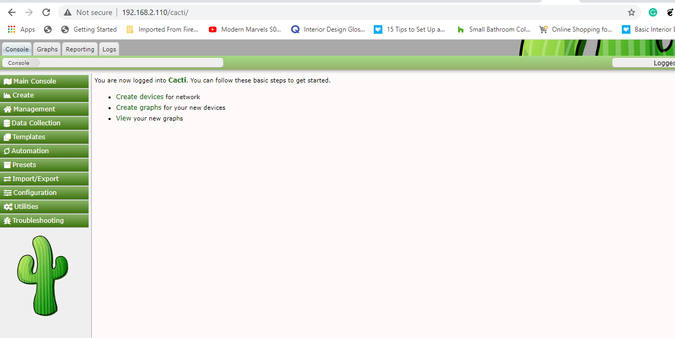

Device Add and + Button Click =>

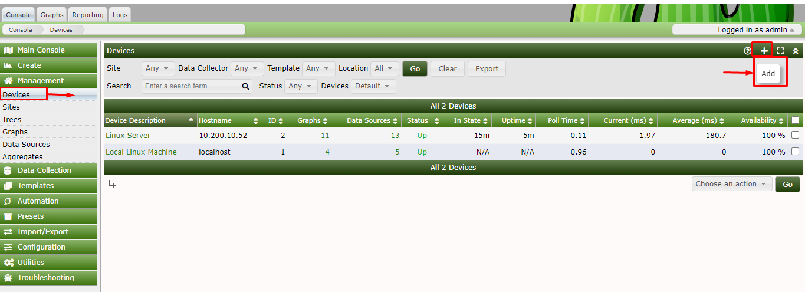

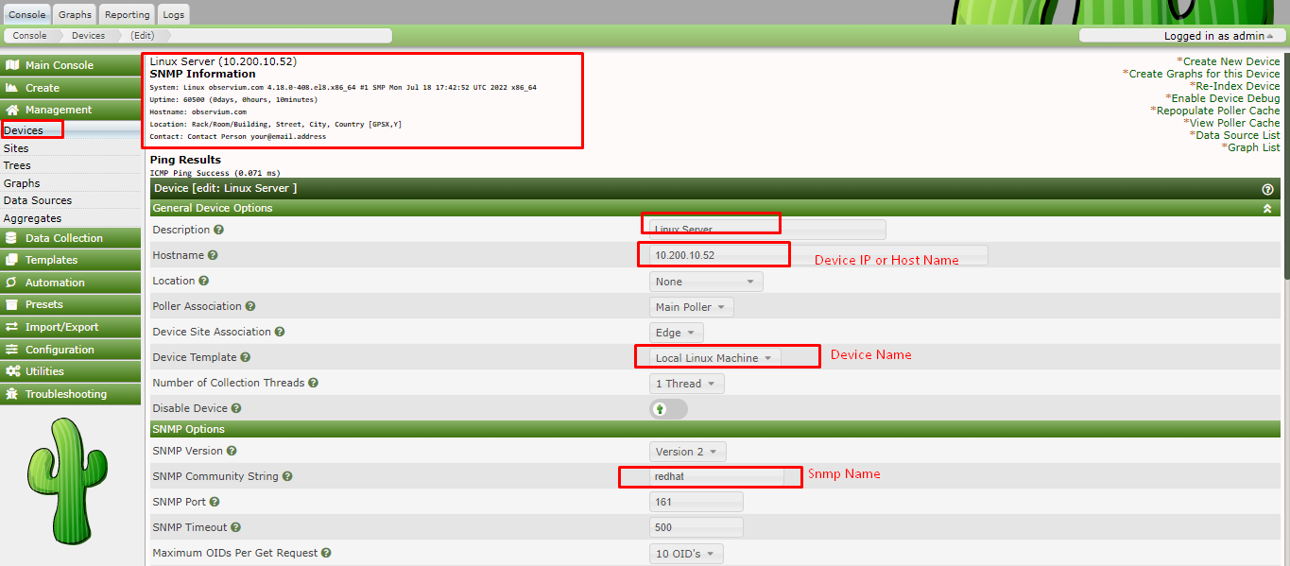

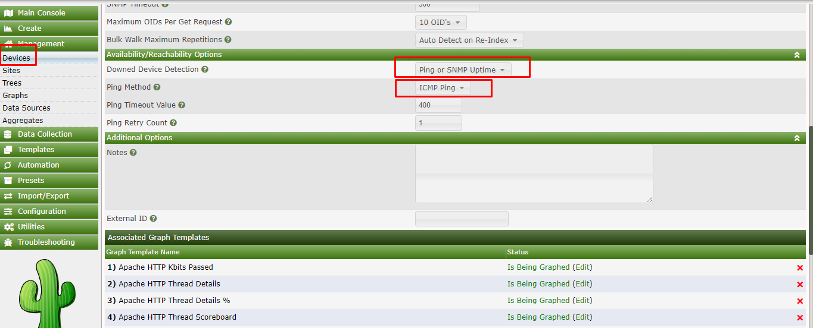

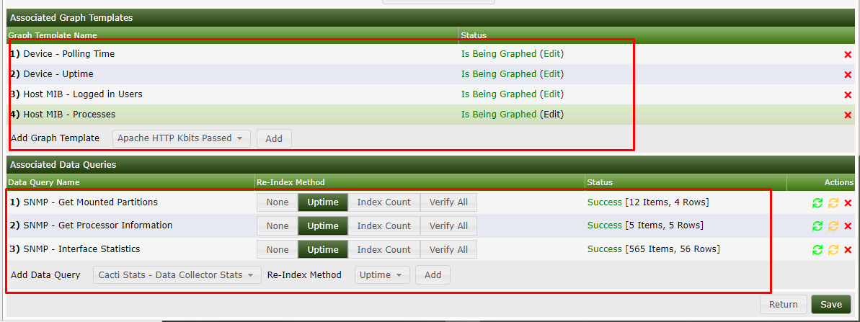

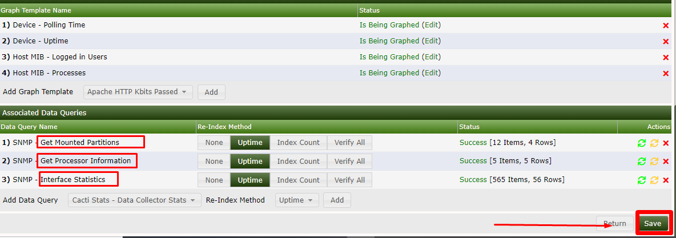

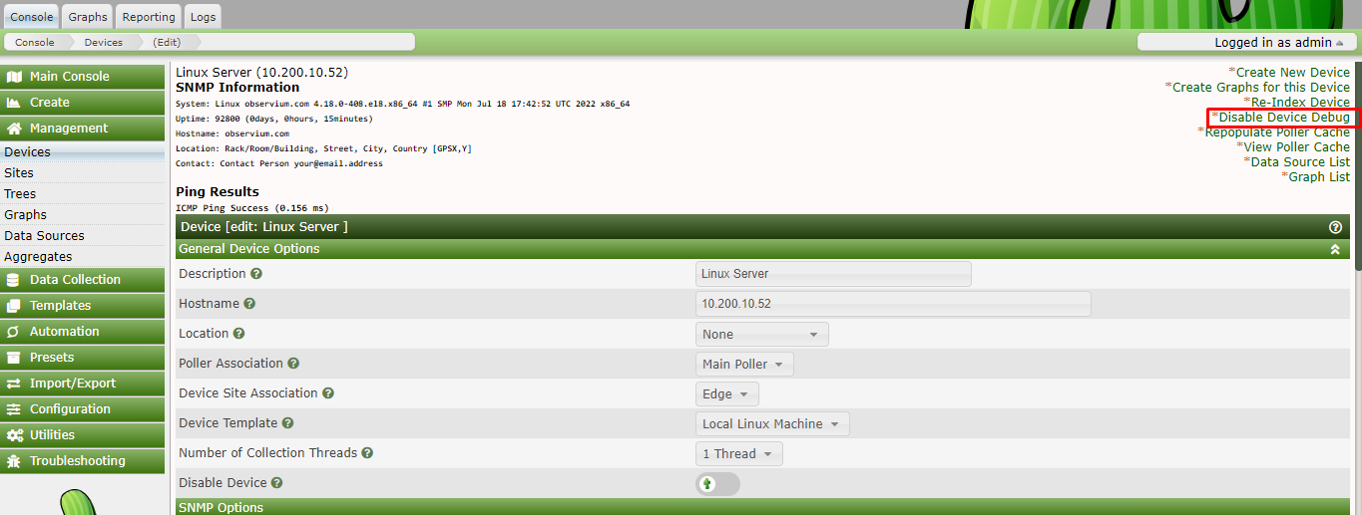

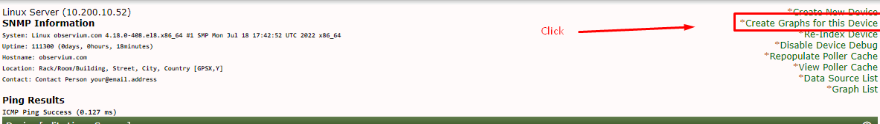

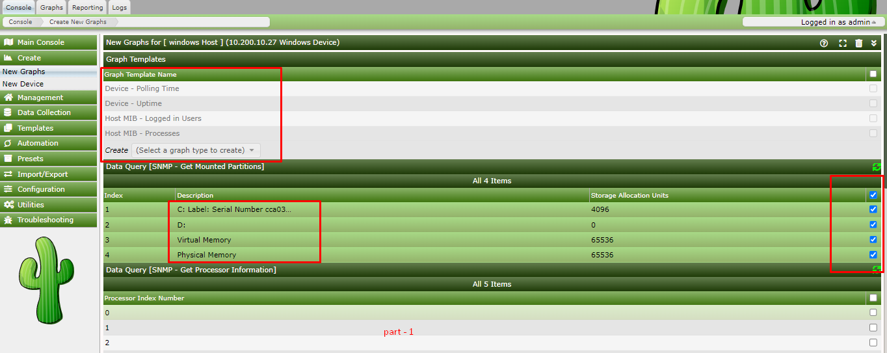

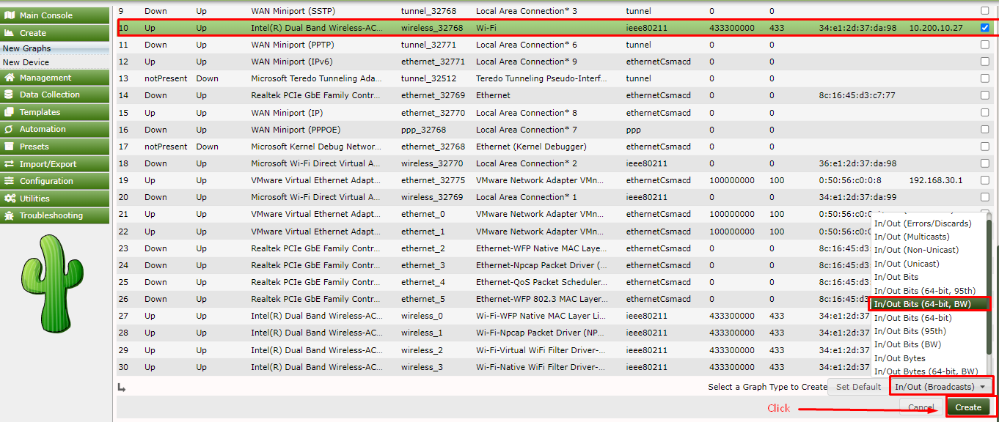

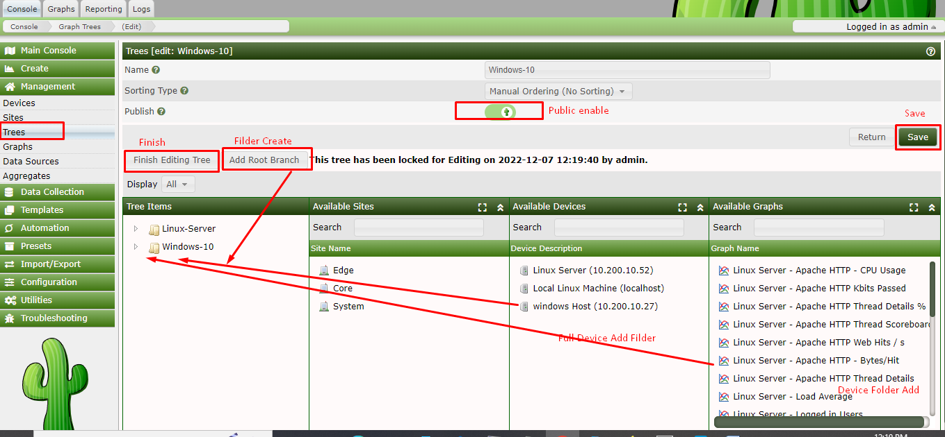

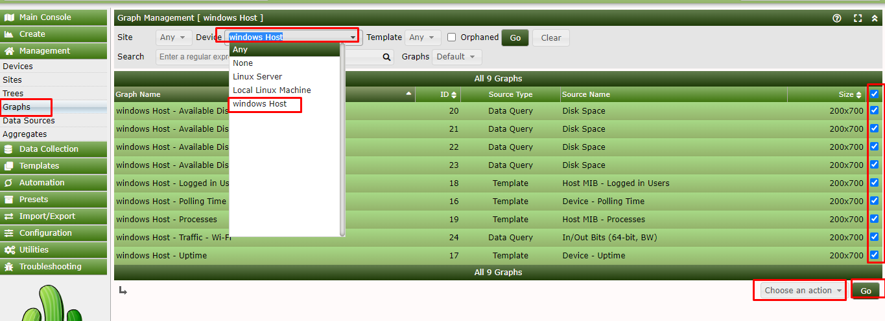

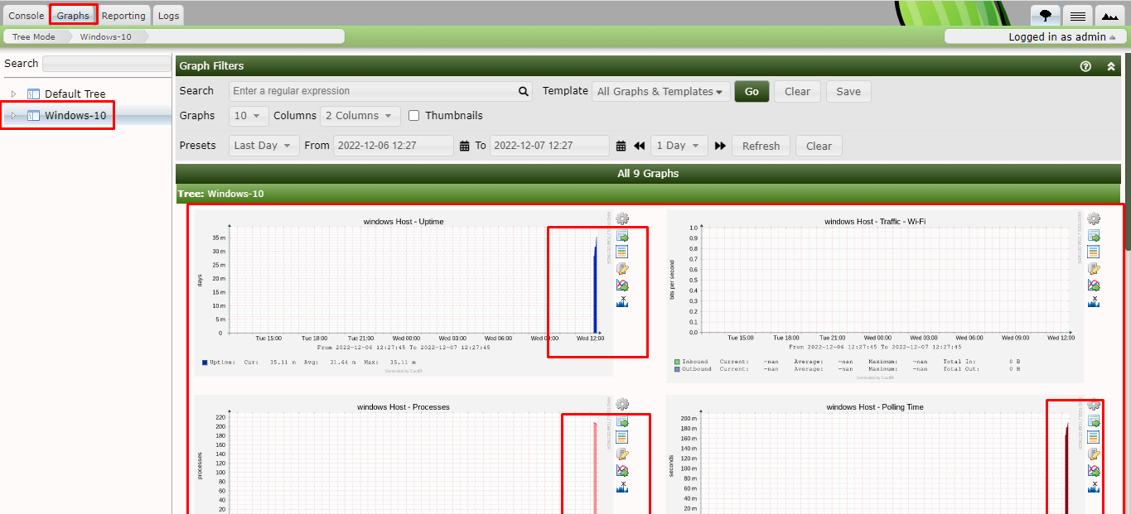

User Add

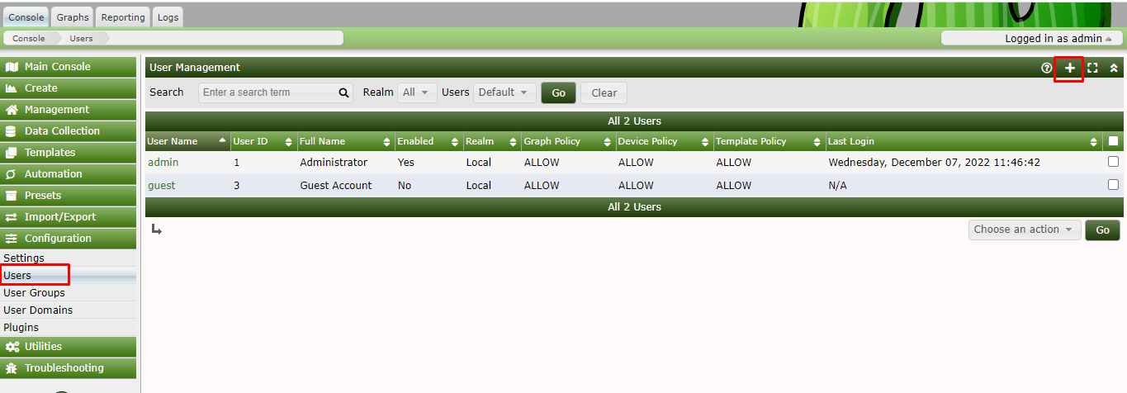

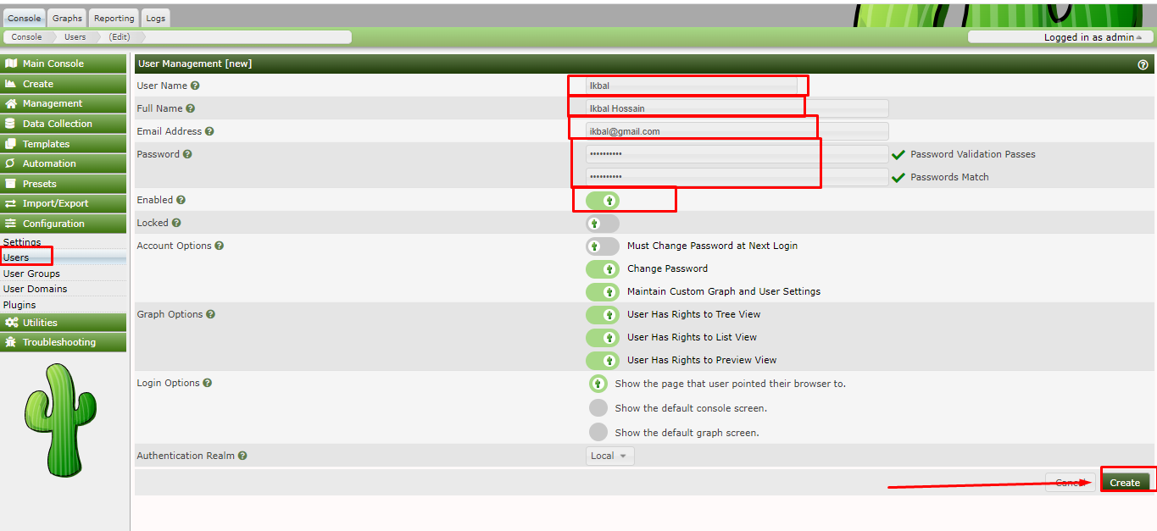

Permission User

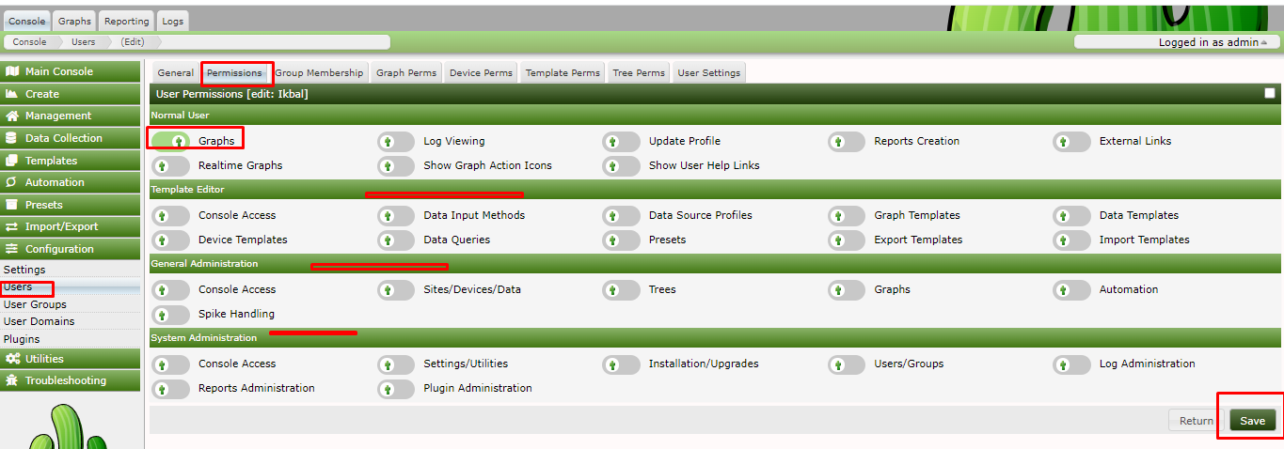

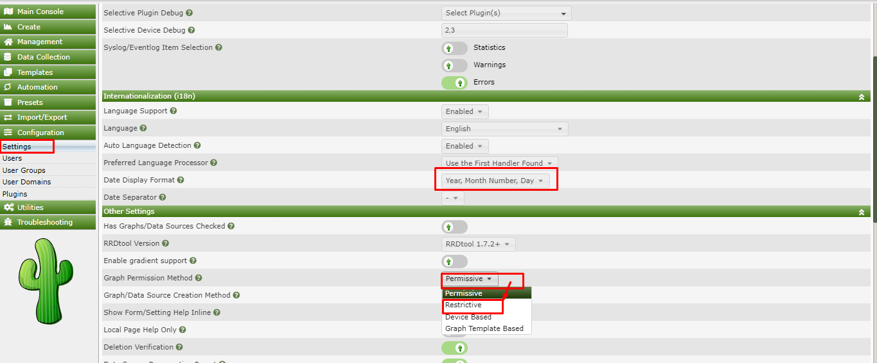

Graphs Permission

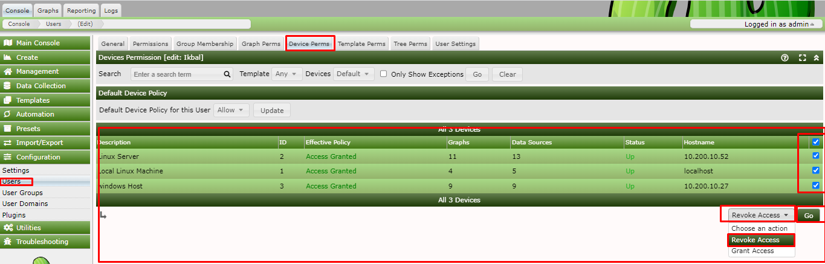

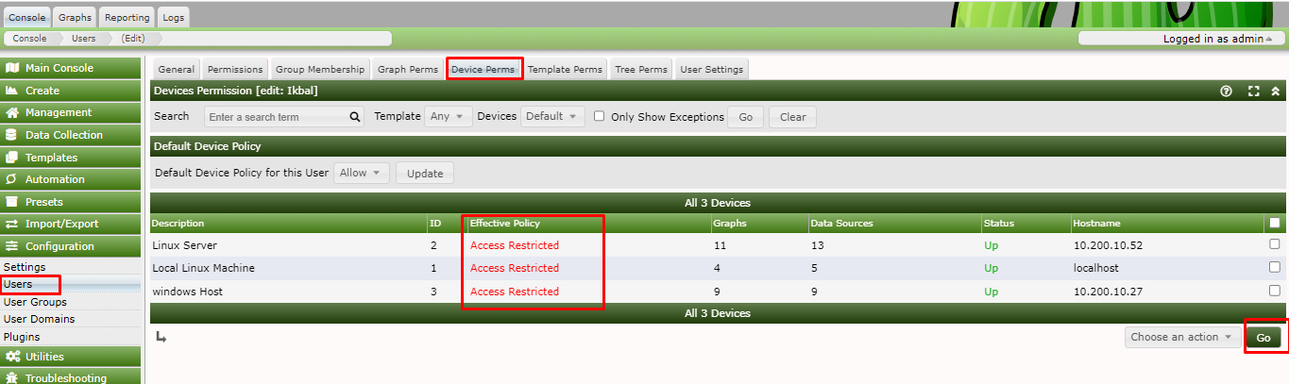

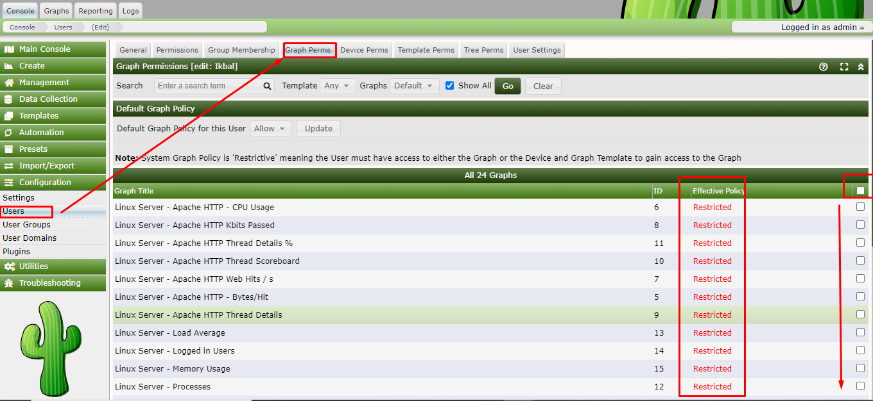

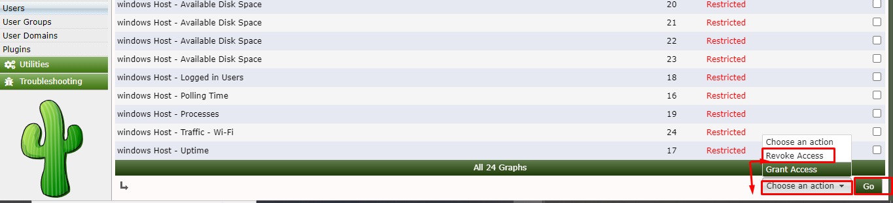

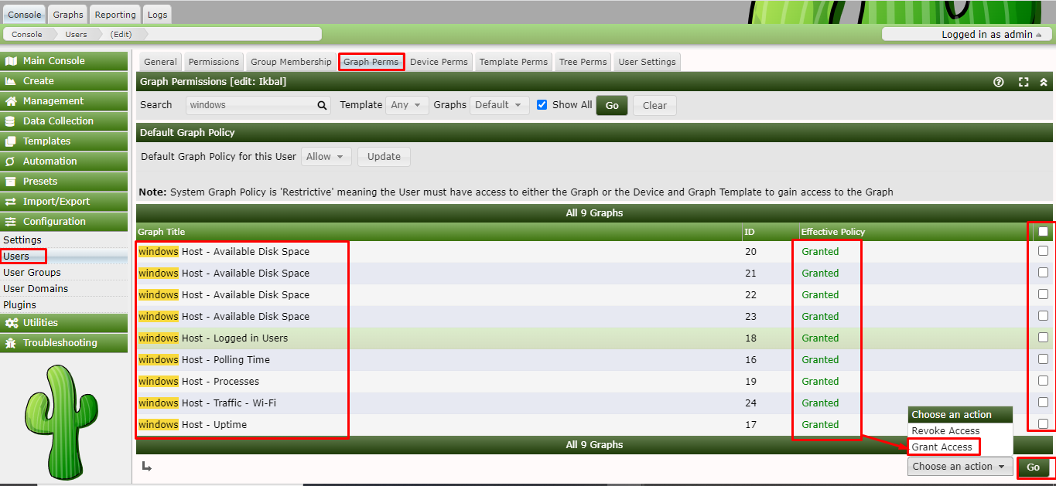

এখানে User Click and Device Perms তার পরে যে Device Permission দেম এই Device Slelect and

Grant Access click and Go Click

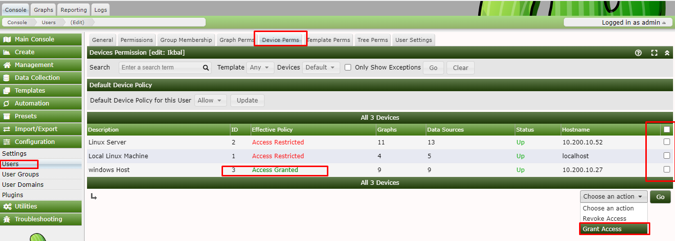

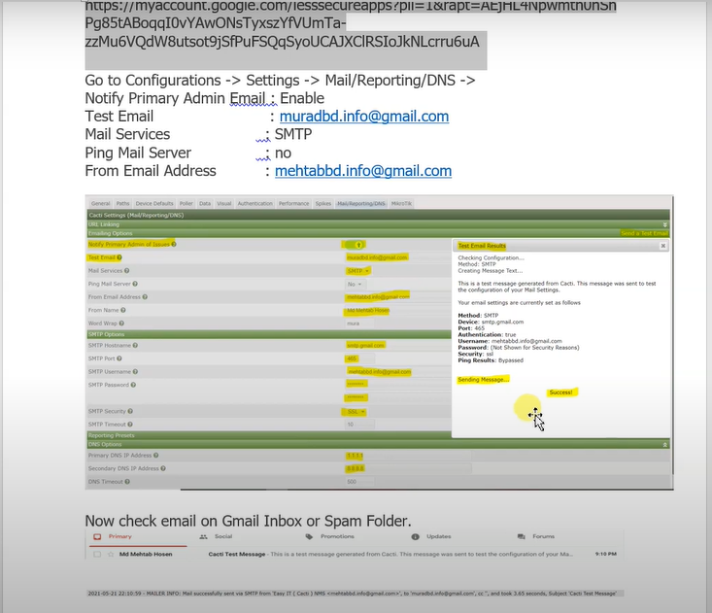

Plugins Install

[root@localhost ~]# cd /usr/share/cacti/plugins/

[root@observium tmp]# cd /var/www/html/cacti/plugins

[root@observium plugins]#wget -O thold.zip <https://github.com/Cacti/plugin_thold/archive/develop.zip>

[root@observium plugins]# unzip thold.zip

[root@observium plugins]# mv plugin_thold-develop thold

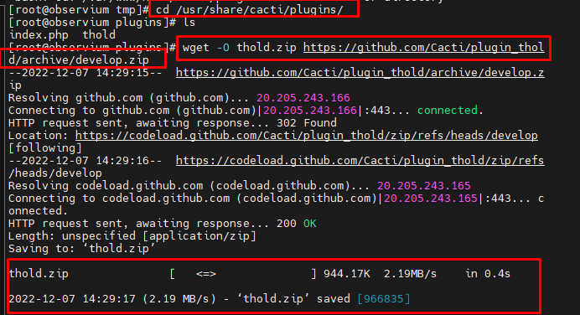

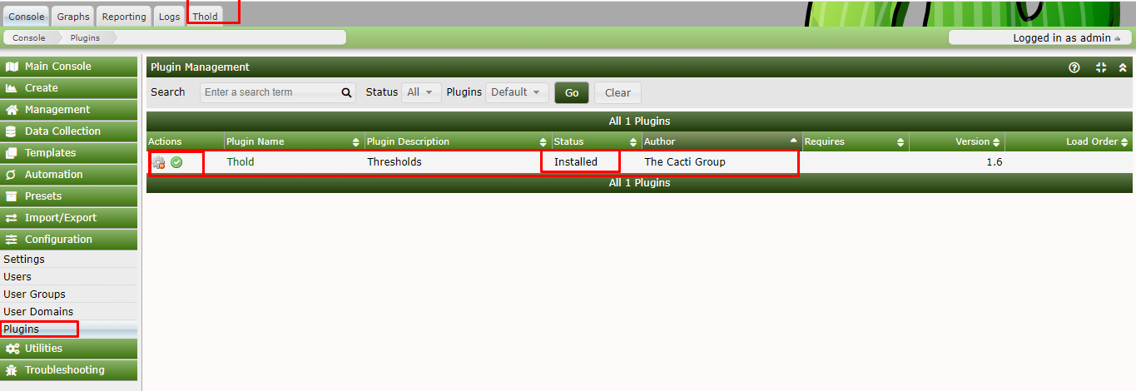

Thold Device Status

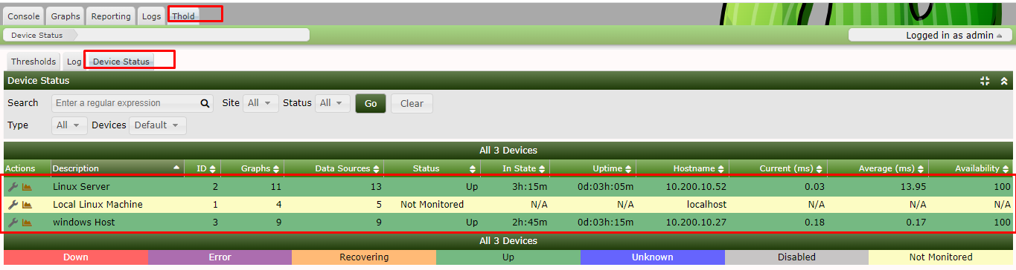

Devices => Mark Option Click and = Global and List Below

=>Notification List => System

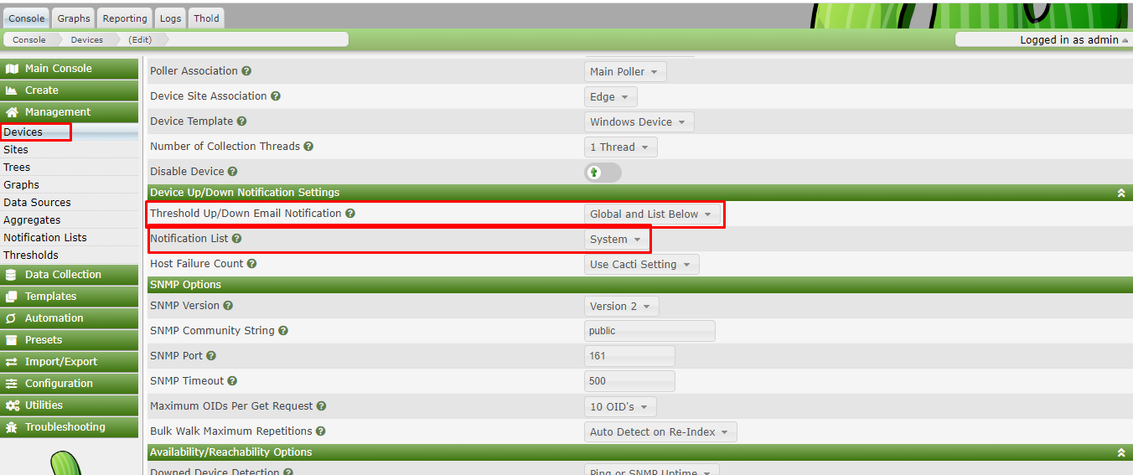

Notification List => [+] Button Click Add Group

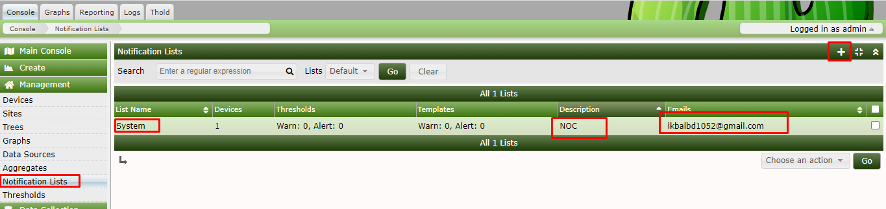

Settings =>Alerting/Thould

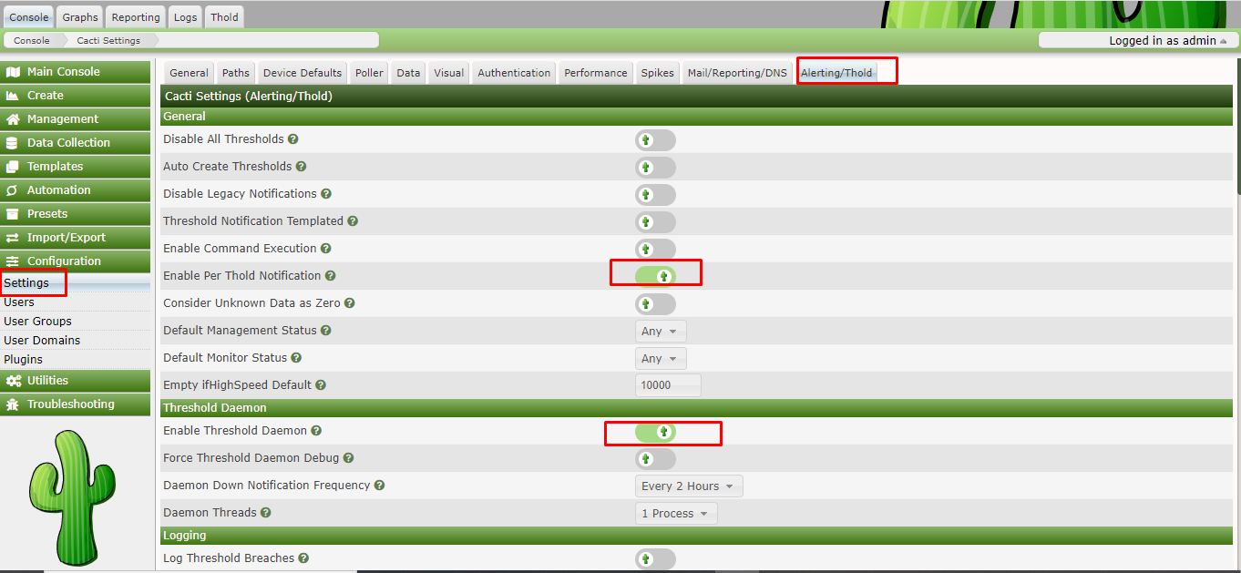

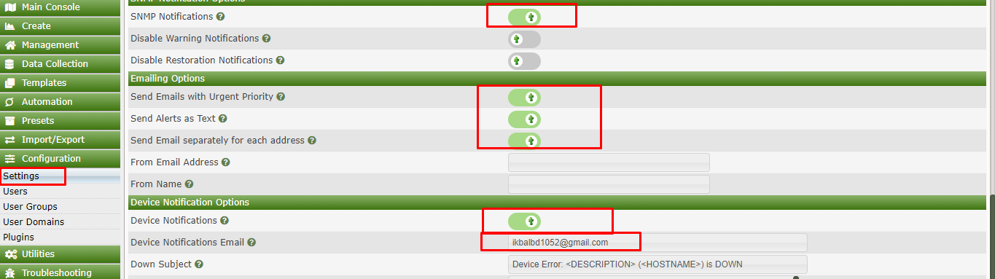

User : admin

Password : Ikbal@0171

Install source :

https://www.linuxtechi.com/install-cacti-monitoring-tool-centos-8-rhel-8/

https://www.linuxtechi.com/category/monitoring-tools/

<https://www.fosslinux.com/7527/how-to-install-and-configure-cacti-on-centos-7.htm>

<https://www.youtube.com/watch?v=rdOmSUbkThw&list=PLrkmsAubb27blmoMNT-p48-qADuxgWaIl&index=10&ab_channel=EasyIT>

https://files.cacti.net/cacti/linux/cacti-1.2.10.tar.gz

systemctl start httpd snmpd mariadb

systemctl enable httpd snmpd mariadb

systemctl restart httpd snmpd mariadb

**http://10.200.6.2/cacti**

User: Admin

Pass: !kbAl@123

User: btrc

Pass: Btrc@1052

User: ikbal

Pass: Ikbal

**Tutorial - Cacti Password Recovery**

First, we need to access the MySQL server as root user.

Use the following command to install the required packages.

# apt-get update //* Ubuntu Server Command  
# apt-get install mysql-client //* Ubuntu Server Command

Use the following command to login the MySQL server as root.

[root@mrtg ~]# mysql -u root –p

Enter password:123

Welcome to the MariaDB monitor. Commands end with ; or \g.

Your MariaDB connection id is 1752

Server version: 10.3.28-MariaDB MariaDB Server

Copyright (c) 2000, 2018, Oracle, MariaDB Corporation Ab and others.

Type 'help;' or '\h' for help. Type '\c' to clear the current input statement.

MariaDB [(none)]>

MariaDB [(none)]> use cacti;

MariaDB [cacti]> update user_auth set password=md5('admin') where username='admin';

MariaDB [(none)]> quit;

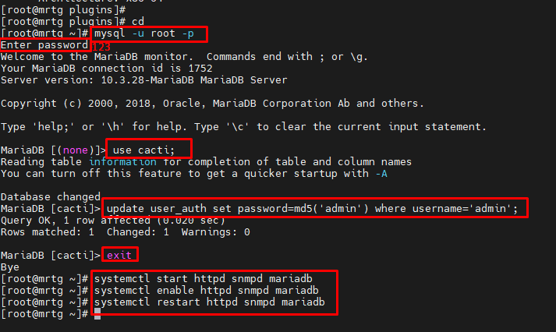

[root@mrtg ~]# cd /usr/share/cacti/plugins

[root@mrtg plugins]# wget <https://github.com/howardjones/network-weathermap/releases/download/version-0.98a/php-weathermap-0.98a.zip>

[root@mrtg plugins]# unzip php-weathermap-0.98a.zip

[root@mrtg plugins]# chmod -R 775 weathermap/configs/

[root@mrtg plugins]# chown -R apache:apache weathermap/configs/

[root@mrtg plugins]# vim weathermap/editor.php

[root@mrtg plugins]#

**Email Alert Notification Set Device.**

**Console => Setting => Mail/Reporting/DNS**

And Finaly Test => **Send a Test Email.**

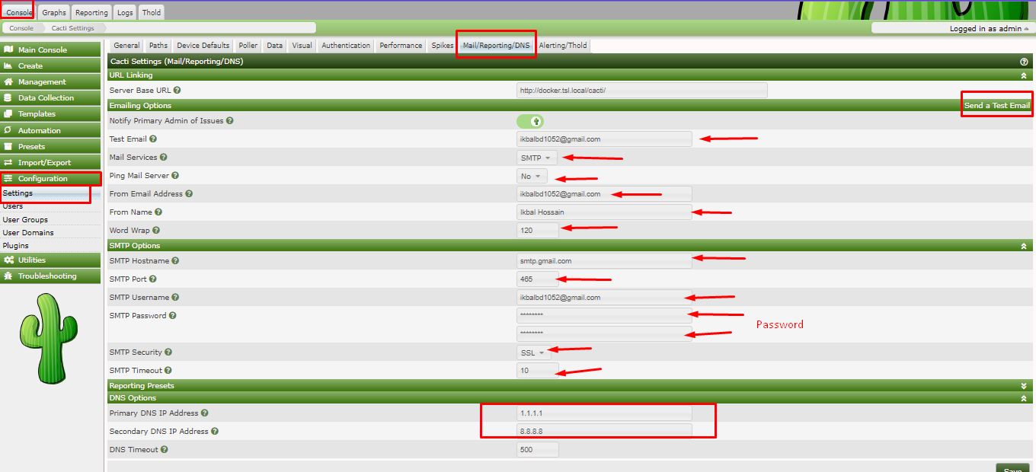

Google Search: gmail app password

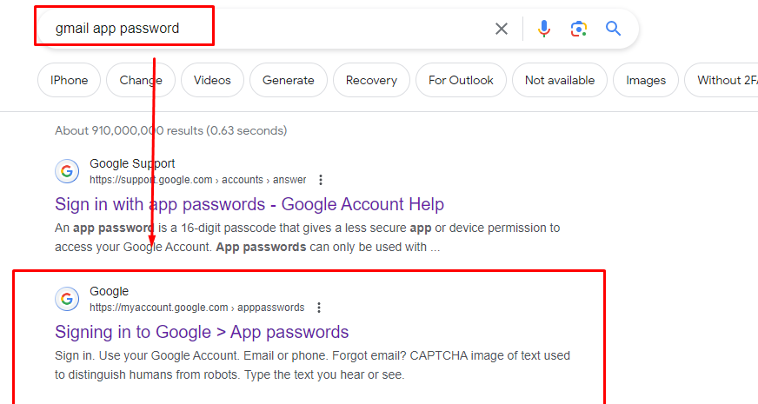

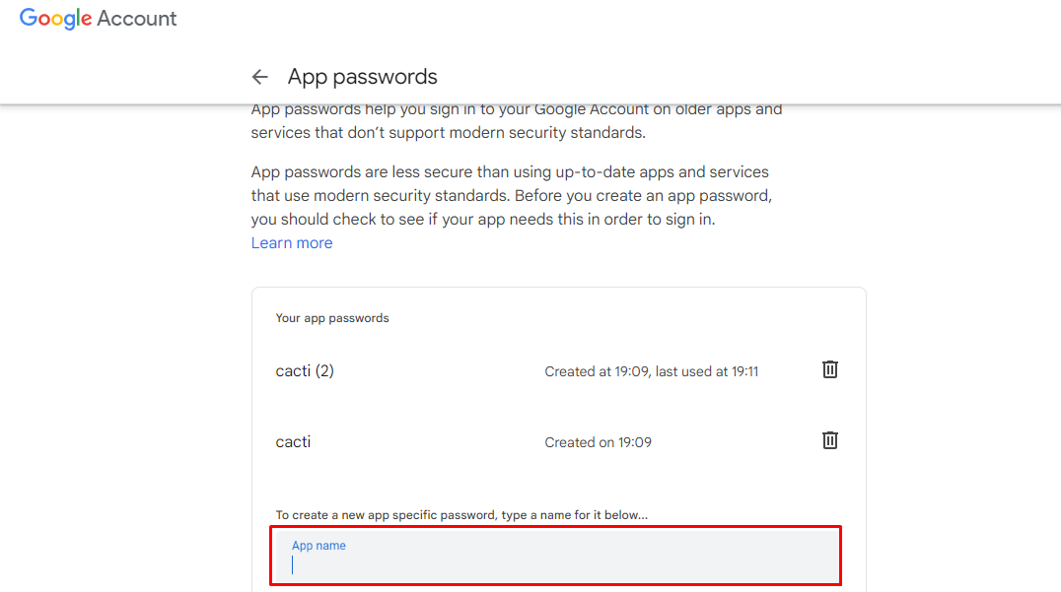

**Note: Gmail App Password ta SMTP Password**.

**Console => Setting => Alerting/Thold**

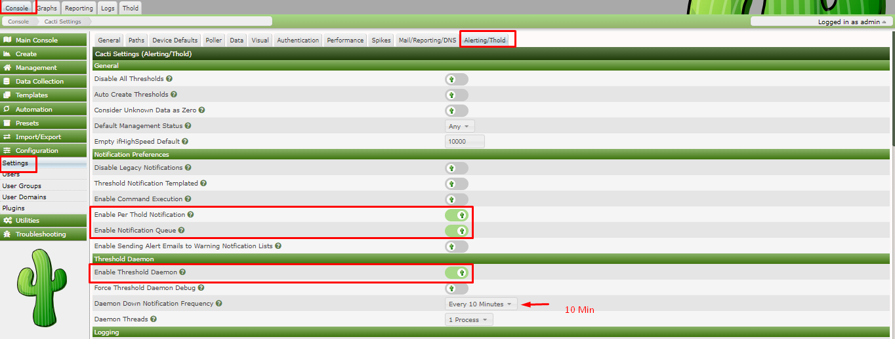

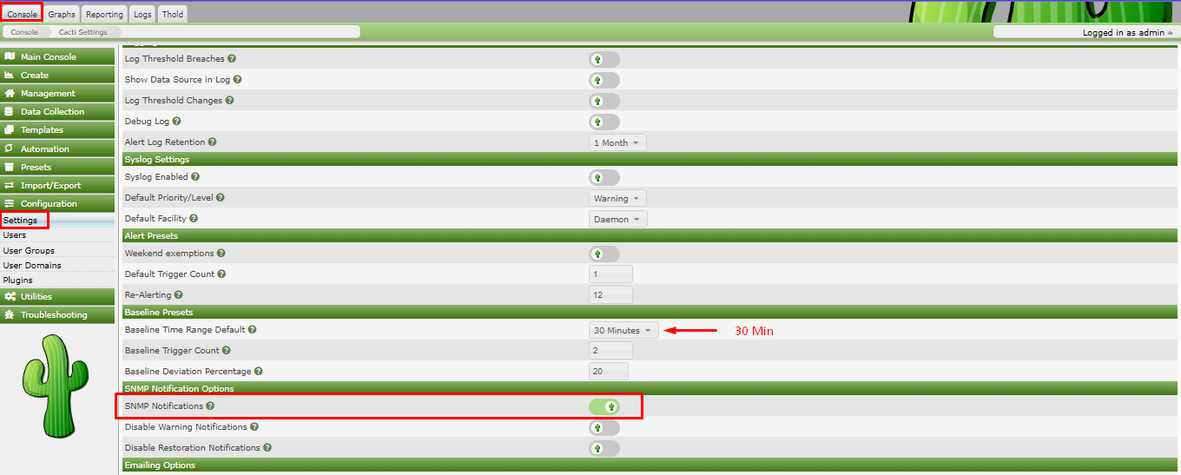

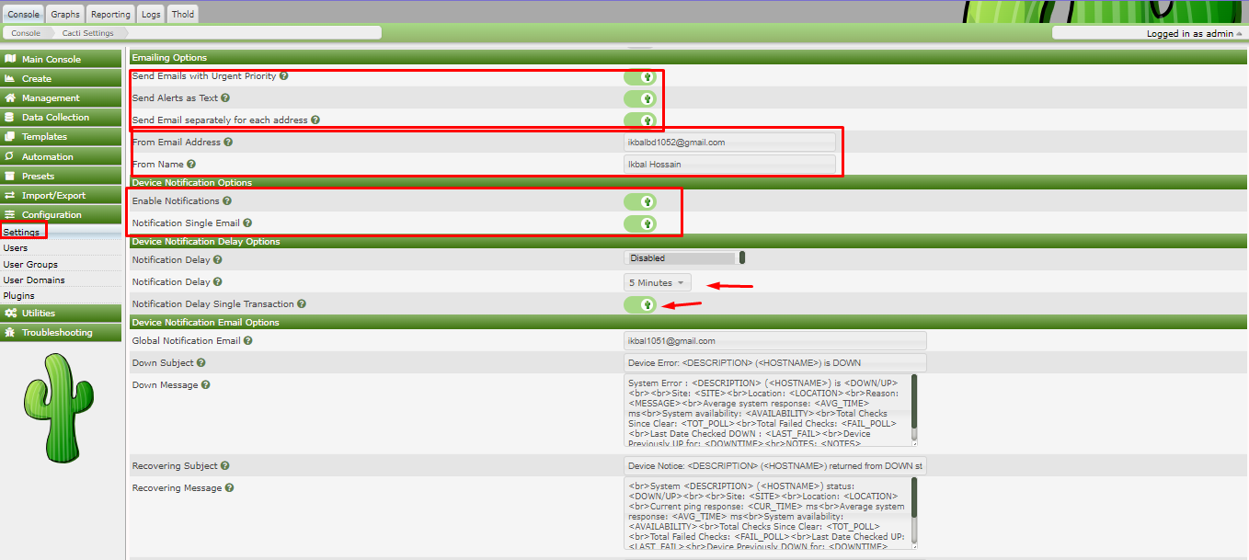

**Console => Management => Notification Lists => ( + ) Add => General**

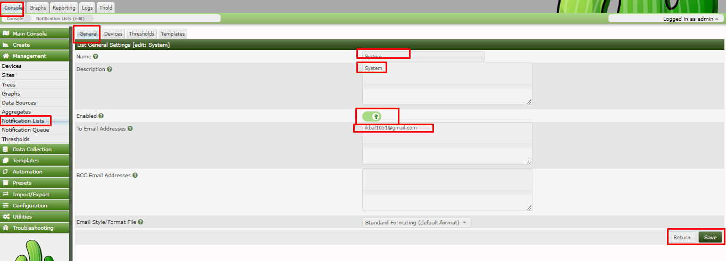

**Console => Management => Devices => (Any Device), Example: Mikrotik**

